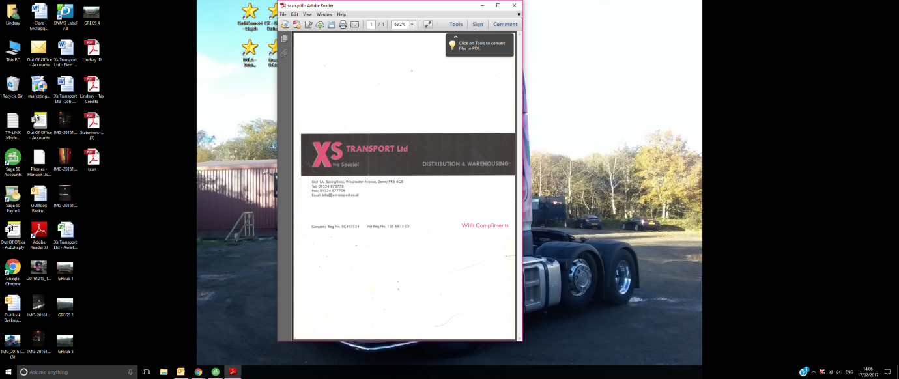

XS TRANSPORT LTD - APPLICATION FOR EMPLOYMENT

PERSONAL v DETAILS

FULL NAME………………………………………………………. D.O.B………………………………….. PLACE OF BIRTH…………………………………
POSITION APPLIED FOR…………………………….… NATIONALITY…………………………… MARITAL STATUS………………………………. ADDRESS……………………………………………………………………………………………………………………….POSTCODE……………………………….
MOBILE……………………………….. LANDLINE………………………….NAT INS NO…………………………………
EMAIL…………………………………………….. CONTACTS OR RELATIVES WITH COMPANY (IF ANY)……………………………………………..

EDUCATION AND TRAINING

SCHOOL /COLLEGE/QUALIFICATIONS…………………………………………………………………...

……………………………………………………………………. AGE LEFT……………………………….. OTHER TRAINING/QUALIFICATIONS……………………………………………………………………………………………………………………………
HAVE YOU APPLIED ON ANY PREVIOUS OCCASION FOR EMPLOYMENT WITH THE COMPANY
………………… IF YES GIVE DETAILS………………………………………………………… LGV LICENCE CLASS (C1, C, C+E)………………………………….
EXPIRY DATE………………………………. LICENCE NO………………………………………………………………………………
ANY ENDORSEMENTS…………………………………………………………………….
PLEASE NOTE: ALL DRIVING LICENCES WILL BE CHECKED WITH DVLA FOR VALIDITY

GIVE DETAILS OF ANY ROAD TRAFFIC ACCIDENTS IN LAST TEN YEARS
……………………………………………………………………………………………………………………………………. HAVE YOU UNDERTAKEN ANY ELEMENTS OF DRIVER CPC YES/NO
IF YES PLEASE GIVE DETAILS……………………………………………………………………………………………..
HAVE YOU HAD ANY SERIOUS ILLNESS, OR HAVE YOU ANY PHYSICAL DISABILITY WHICH MIGHT AFFECT YOUR EMPLOYMENT?

…………………………………………………………………………………………………………………………………………………………………………

…………………………………………………………………………………………………………………………………………………………………………..

HAVE YOU ANY CRIMINAL CONVICTIONS? .........................................................................................................

IF SO, GIVE BRIEF DETAILS………………………………………………………………………………………………………………………………..

POLICE CHECKS WILL BE CARRIED OUT.

ANY OFFER OF EMPLOYMENT IS SUBJECT TO THE RECEIPT OF SATISFACTORY MEDICAL INFORMATION WHICH MAY ENTAIL A MEDICAL EXAMINATION

EMPLOYMENT HISTORY
1. PRESENT/LAST EMPLOYERS NAME | 2.PREVIOUS EMPLOYERS NAME | 3.PREVIOUS EMPLOYERS NAME
…………………………………………….. | ………………………………………….. | ………………………………………………...

JOB TITLE………………………………. JOB TITLE.………………………… JOB TITLE…………………………… DUTIES………………………….......... DUTIES……………………………… DUTIES…………………………………
CONTACT NAME ……………........ CONTACT NAME………………… CONTACT NAME………………….
CONTACT NO.……………….......... CONTACT NO…………………….. CONTACT NO……………………….
LENGTH OF SERVICE LENGTH OF SERVICE LENGTH OF SERVICE
……………………………………… ………………………………….. …………………………….
REASON FOR LEAVING REASON FOR LEAVING REASON FOR LEAVING
…………………………………….. …………………………………….. ………………………………………..

SOURCE OF INTRODUCTION:
ADVERTISEMENT/JOBCENTRE/RECOMMENDED BY; ……………………………………………………….

ADDITIONAL INFORMATION

DO YOU HAVE MULTI DROP EXPERIENCE? YES/NO

PLEASE GIVE EXAMPLES OF TYPES OF TRAILERS USED AND EXPERIENCE GAINED

………………………………………………………………………………………………………………………………
HAS ANY INSURER AT ANY TIME:-

DECLINED YOUR PROPOSAL FOR INSURANCE? YES/NO IF YES PLEASE GIVE DETAILS
………………………………………………………………………………………………………………………………………………………………………………….
REQUIRED ANY SPECIAL CONDITIONS ON YOUR POLICY? YES/NO IF YES PLEASE GIVE DETAILS
………………………………………………………………………………………………………………………………………………………………………………..
CANCELLED OR REFUSED TO RENEW YOUR POLICY? YES/NO IF YES PLEASE GIVE DETAILS
………………………………………………………………………………………………………………………………………………………………………………..
DO YOU REQUIRE THE USE OF GLASSES/CONTACT LENSES FOR DRIVING? YES/NO
ARE YOU PREPARED TO UNDERGO A MEDICAL EXAMINATION? YES/NO

DO YOU HAVE MEMBERSHIP OF A PROFESSIONAL ORGANISATION? YES/NO IF YES PLEASE
GIVE DETAILS

………………………………………………………………………………………………………..……………………………………………………………………………………………

NOTE: NEW EMPLOYEES RECEIVE A JOB INDUCTION & FULL TRAINING WHERE REQUIRED. IF YOU LEAVE DURING THE FIRST WEEK, YOU WILL NOT BE PAID FOR TRAINING DAYS.

Please note by signing below you are happy for us to keep your details on file for prospective employment opportunities. If at any time you wish for these details to be removed from our files, please do not hesitate to contact us.

APPLICANTS SIGNATURE……………………………………… DATE………………………

